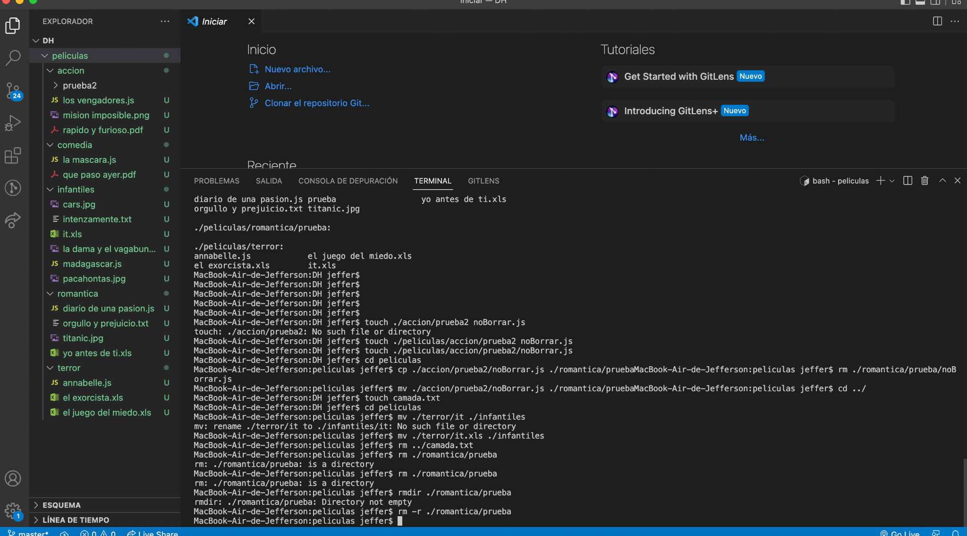

MacBook-Air-de-Jefferson:accion jeffer$ mv "el hexorcista.xls" ../terror

MacBook-Air-de-Jefferson:accion jeffer$ cd ../comedia

MacBook-Air-de-Jefferson:comedia jeffer$ mv it.xls ../terror

MacBook-Air-de-Jefferson:comedia jeffer$ mv madagaskar.js ../infantiles

MacBook-Air-de-Jefferson:comedia jeffer$ mv "mision imposible.png" ../accion

MacBook-Air-de-Jefferson:comedia jeffer$ mv "orgullo y prejuicion.txt" ../romanticaMacBook-Air-de-Jefferson:comedia jeffer$ cd ../infantiles

MacBook-Air-de-Jefferson:infantiles jeffer$ mv "el juego del miedo.xls" ../terror

MacBook-Air-de-Jefferson:infantiles jeffer$ mv "rapido y furioso.pdf" ../accion

MacBook-Air-de-Jefferson:infantiles jeffer$ mv titanic.jpg ../romantica

MacBook-Air-de-Jefferson:infantiles jeffer$ mv "diario de una pasion.js" ../romantica

MacBook-Air-de-Jefferson:infantiles jeffer$ cd ../romantica

MacBook-Air-de-Jefferson:romantica jeffer$ mv annabelle.js ../terror

MacBook-Air-de-Jefferson:romantica jeffer$ mv "la mascara.js" ../comedia

MacBook-Air-de-Jefferson:romantica jeffer$ mv "los vengadores.js" ../accion

MacBook-Air-de-Jefferson:romantica jeffer$ mv pacahontas.jpg ../infantiles

MacBook-Air-de-Jefferson:romantica jeffer$ mv "que paso ayer.pdf" ../comedia

mv: rename que paso ayer.pdf to ../comedia/que paso ayer.pdf: No such file or directory

MacBook-Air-de-Jefferson:romantica jeffer$ cd ../terror

MacBook-Air-de-Jefferson:terror jeffer$ mv "que paso ayer.pdf" ../comedia

MacBook-Air-de-Jefferson:terror jeffer$ mv "yo antes de ti.xls" ../romantica

MacBook-Air-de-Jefferson:terror jeffer$ mv "la dama y el bagavundo.png" ../infantiles

MacBook-Air-de-Jefferson:terror jeffer$ cd ../../

MacBook-Air-de-Jefferson:DH jeffer$ mv ./infantiles intenzamente.txt/intensamente.txt

mv: rename ./infantiles to intenzamente.txt/intensamente.txt: No such file or directory

MacBook-Air-de-Jefferson:DH jeffer$ mv ./infantiles intenzamente.txt a intensamente.txt

mv: intensamente.txt is not a directory

MacBook-Air-de-Jefferson:DH jeffer$ mv intenzamente.txt a intensamente.txt

mv: intensamente.txt is not a directory

MacBook-Air-de-Jefferson:DH jeffer$ mv ./infantiles intenzamente.txt/intensamente.txt

mv: rename ./infantiles to intenzamente.txt/intensamente.txt: No such file or directory

MacBook-Air-de-Jefferson:DH jeffer$ mv ../infantiles touch intenzamente.txt a intensamente.xt

mv: intensamente.xt is not a directory

MacBook-Air-de-Jefferson:DH jeffer$ cd ./infantiles mv intensamente.txt a intensamente.txt

bash: cd: ./infantiles: No such file or directory

MacBook-Air-de-Jefferson:DH jeffer$ mv ./infantiles intenzamente.txt/intensamente.txt

mv: rename ./infantiles to intenzamente.txt/intensamente.txt: No such file or directory

MacBook-Air-de-Jefferson:DH jeffer$ rename ./infantiles intenzamente.txt a intensamente.txt

bash: rename: command not found

MacBook-Air-de-Jefferson:DH jeffer$ mv inten

* Historial restaurado

The default interactive shell is now zsh.

To update your account to use zsh, please run `chsh -s /bin/zsh`.

For more details, please visit https://support.apple.com/kb/HT208050.

MacBook-Air-de-Jefferson:DH jeffer$ mv ./infantiles intenzamente.txt/intensamente.txt

mv: rename ./infantiles to intenzamente.txt/intensamente.txt: No such file or directory

MacBook-Air-de-Jefferson:DH jeffer$ mv ./infantiles /intenzamente.txt/intensamente.txt

mv: rename ./infantiles to /intenzamente.txt/intensamente.txt: No such file or directory

MacBook-Air-de-Jefferson:DH jeffer$ mv ./infantiles/intenzamente.txt a intensamente.txt

mv: intensamente.txt is not a directory

MacBook-Air-de-Jefferson:DH jeffer$ mv ./infantiles.intenzamente.txt/intensamente.txt

usage: mv [-f | -i | -n] [-v] source target

mv [-f | -i | -n] [-v] source ... directory

MacBook-Air-de-Jefferson:DH jeffer$ mv ./infantiles/intenzamente.txt/intensamente.txt

usage: mv [-f | -i | -n] [-v] source target

mv [-f | -i | -n] [-v] source ... directory

MacBook-Air-de-Jefferson:DH jeffer$ mv ./infantiles/intenzamente.txt/intensamente.txt/

usage: mv [-f | -i | -n] [-v] source target

mv [-f | -i | -n] [-v] source ... directory

MacBook-Air-de-Jefferson:DH jeffer$ mv ./infantiles/intenzamente.txt/intensamente.txt

usage: mv [-f | -i | -n] [-v] source target

mv [-f | -i | -n] [-v] source ... directory

MacBook-Air-de-Jefferson:DH jeffer$ mv ./infantiles/intenzamente.txt comedia

mv: rename ./infantiles/intenzamente.txt to comedia: No such file or directory

MacBook-Air-de-Jefferson:DH jeffer$ mv ./infantiles intenzamente.txt comedia

mv: comedia is not a directory

MacBook-Air-de-Jefferson:DH jeffer$ mv ./infantiles/intenzamente.txt ../comedia

mv: rename ./infantiles/intenzamente.txt to ../comedia: No such file or directory

MacBook-Air-de-Jefferson:DH jeffer$ mv ./infantiles intenzamente.txt ../comedia

mv: ../comedia is not a directory

MacBook-Air-de-Jefferson:DH jeffer$ mv intenzamente.txt intensamente.txt

mv: rename intenzamente.txt to intensamente.txt: No such file or directory

MacBook-Air-de-Jefferson:DH jeffer$ mv intenzamente.txt/intensamente.txt

usage: mv [-f | -i | -n] [-v] source target

mv [-f | -i | -n] [-v] source ... directory

MacBook-Air-de-Jefferson:DH jeffer$ mv intenzamente.txt a intensamente.txt

mv: intensamente.txt is not a directory

MacBook-Air-de-Jefferson:DH jeffer$ mv [./infantiles/intenzamente.txt] [./infantiles/intensamente.txt]

mv: rename [./infantiles/intenzamente.txt] to [./infantiles/intensamente.txt]: No such file or directory

MacBook-Air-de-Jefferson:DH jeffer$ mv [./infantiles/intenzamente.txt ./infantiles/intensamente.txt]

mv: rename [./infantiles/intenzamente.txt to ./infantiles/intensamente.txt]: No such file or directory

MacBook-Air-de-Jefferson:DH jeffer$ mv ./infantiles intenzamente.txt/intensamente

mv: rename ./infantiles to intenzamente.txt/intensamente: No such file or directory

MacBook-Air-de-Jefferson:DH jeffer$ mv ./infantiles [inzamente.txt/intensmente]

mv: rename ./infantiles to [inzamente.txt/intensmente]: No such file or directory

MacBook-Air-de-Jefferson:DH jeffer$ mv /peliculas/infantiles intenzamente.txt/intensamente

mv: rename /peliculas/infantiles to intenzamente.txt/intensamente: No such file or directory

MacBook-Air-de-Jefferson:DH jeffer$ mv ./intantiles/ intenzamente.txt ./infantiles/intensamente.txt

mv: ./infantiles/intensamente.txt is not a directory

MacBook-Air-de-Jefferson:DH jeffer$ ./peliculas/infantiles/intenzamente.txt ./peliculas/infantiles/intensamente.txt

bash: ./peliculas/infantiles/intenzamente.txt: Permission denied

MacBook-Air-de-Jefferson:DH jeffer$ ./peliculas/infantiles/intenzamente.txt ./peliculas/infantiles/intensamente.txt

bash: ./peliculas/infantiles/intenzamente.txt: Permission denied

MacBook-Air-de-Jefferson:DH jeffer$ mv ./peliculas/infantiles/intenzamente.txt ./peliculas/infantiles/intensamente.txt

MacBook-Air-de-Jefferson:DH jeffer$ mv ./infantiles/intensamente.txt ./infantiles/intenzamente.txt

mv: rename ./infantiles/intensamente.txt to ./infantiles/intenzamente.txt: No such file or directory

MacBook-Air-de-Jefferson:DH jeffer$ mv ./peliculas/infantiles/intensamente.txt ./peliculas/infantiles/intenzamente.txt

MacBook-Air-de-Jefferson:DH jeffer$ mv ./peliculas/infantiles/madagaskar.js ./peliculas/infantiles/madagascar.js

MacBook-Air-de-Jefferson:DH jeffer$ mv ./peliculas/infantiles/"la dama y el bagavundo.png" ./peliculas/infantiles/"la dama y el vagabundo.png"

MacBook-Air-de-Jefferson:DH jeffer$ mv ./peliculas/romantica/"orgullo y prejuicion.txt" ./peliculas/romantica/"orgullo y prejuicio"

MacBook-Air-de-Jefferson:DH jeffer$ mv ./peliculas/romantica/"orgullo y prejuicion.txt" ./peliculas/romantica/"orgullo y prejuicio.txt"

mv: rename ./peliculas/romantica/orgullo y prejuicion.txt to ./peliculas/romantica/orgullo y prejuicio.txt: No such file or directory

MacBook-Air-de-Jefferson:DH jeffer$ mv ./peliculas/romantica/"orgullo y prejuicion" ./peliculas/romantica/"orgullo y prejuicio.txt"

mv: rename ./peliculas/romantica/orgullo y prejuicion to ./peliculas/romantica/orgullo y prejuicio.txt: No such file or directory

MacBook-Air-de-Jefferson:DH jeffer$ mv ./peliculas/romantica/"orgullo y prejuicio" ./peliculas/romantica/"orgullo y prejuicio.txt"

MacBook-Air-de-Jefferson:DH jeffer$ mv ./peliculas/terror/"el hexorcista.xls" ./pel

iculas/terror/"el exorcista.xls"

MacBook-Air-de-Jefferson:DH jeffer$ rm ./peliculas/accion/"smooth criminal.txt"

MacBook-Air-de-Jefferson:DH jeffer$ rm ./peliculas/terror/"we will rock you.js"

MacBook-Air-de-Jefferson:DH jeffer$ ls -a

. .. .DS_Store .git peliculas

MacBook-Air-de-Jefferson:DH jeffer$ ls -r

peliculas

MacBook-Air-de-Jefferson:DH jeffer$ ls -R

peliculas

./peliculas:

accion comedia infantiles romantica terror

./peliculas/accion:

los vengadores.js prueba2

mision imposible.png rapido y furioso.pdf

./peliculas/accion/prueba2:

./peliculas/comedia:

la mascara.js que paso ayer.pdf

./peliculas/infantiles:

cars.jpg madagascar.js

intenzamente.txt pacahontas.jpg

la dama y el vagabundo.png

./peliculas/romantica:

diario de una pasion.js prueba yo antes de ti.xls

orgullo y prejuicio.txt titanic.jpg

./peliculas/romantica/prueba:

./peliculas/terror:

annabelle.js el juego del miedo.xls

el exorcista.xls it.xls

MacBook-Air-de-Jefferson:DH jeffer$

MacBook-Air-de-Jefferson:DH jeffer$

MacBook-Air-de-Jefferson:DH jeffer$

MacBook-Air-de-Jefferson:DH jeffer$

MacBook-Air-de-Jefferson:DH jeffer$

MacBook-Air-de-Jefferson:DH jeffer$ touch ./accion/prueba2 noBorrar.js

touch: ./accion/prueba2: No such file or directory

MacBook-Air-de-Jefferson:DH jeffer$ touch ./peliculas/accion/prueba2 noBorrar.js

MacBook-Air-de-Jefferson:DH jeffer$ touch ./peliculas/accion/prueba2/noBorrar.js

MacBook-Air-de-Jefferson:DH jeffer$ cd peliculas

MacBook-Air-de-Jefferson:peliculas jeffer$ cp ./accion/prueba2/noBorrar.js ./romantica/pruebaMacBook-Air-de-Jefferson:peliculas jeffer$ rm ./romantica/prueba/noBorrar.js

MacBook-Air-de-Jefferson:peliculas jeffer$ mv ./accion/prueba2/noBorrar.js ./romantica/pruebaMacBook-Air-de-Jefferson:peliculas jeffer$ cd ../

MacBook-Air-de-Jefferson:DH jeffer$ touch camada.txt

MacBook-Air-de-Jefferson:DH jeffer$ cd peliculas

MacBook-Air-de-Jefferson:peliculas jeffer$ mv ./terror/it ./infantiles

mv: rename ./terror/it to ./infantiles/it: No such file or directory

MacBook-Air-de-Jefferson:peliculas jeffer$ mv ./terror/it.xls ./infantiles

MacBook-Air-de-Jefferson:peliculas jeffer$ rm ../camada.txt

MacBook-Air-de-Jefferson:peliculas jeffer$ rm ./romantica/prueba

rm: ./romantica/prueba: is a directory

MacBook-Air-de-Jefferson:peliculas jeffer$ rm ./romantica/prueba

rm: ./romantica/prueba: is a directory

MacBook-Air-de-Jefferson:peliculas jeffer$ rmdir ./romantica/prueba

rmdir: ./romantica/prueba: Directory not empty

MacBook-Air-de-Jefferson:peliculas jeffer$ rm -r ./romantica/prueba

MacBook-Air-de-Jefferson:peliculas jeffer$